CAPK Issue in BBPOS Chipper Line (Walker)

If a user does NOT update the firmware, the reader will cease to be able to successfully do EMV transactions after Dec 31, 2021.

Issue: Due to a function of the current firmware structure, CAPKs cannot be accessed beyond Dec 31, 2021. This will result in failed transactions beyond that date.

Solution: Firmware must be updated. No action is required in the config or CAPK file. After this update, the reader will continue to successfully execute EMV transactions.

The following table shows what version of firmware corrects the CAPK issue for each Walker device:
Product | Firmware Resolution
Walker 2.0 BT (CHB10) | 1.00.03.35
Walker C2X (CHC2X) audio | 06.35.84.50aeed7b
Walker C2XBT (CHB20) | 1.00.03.47
Walker C2XBT (CHB22) | 1.01.03.12
Walker C2XBT (CHB29) | 1.02.00.04
Walker C2XBT (CHB2A) | 1.03.00.04

Update options:
- An integrator can implement OTA (over-the-air) updates for the readers. This is the preferred/free option.
  - If the app uses the AnywhereCommerce AnyPay SDK, then Download the platform specific OTA SDK from https://developer.bbpos.com/anywherecommerce
  - If the ISV uses the AnyPay SDKs, you can activate OTA within the app.
    - iOS – AnyPay for iOS
    - Android – AnyPay for Android
  - If the app uses the BBPOS BBDEVICE library, then you can add the OTA SDK that corresponds to the BBDEVICE library
    - Android BBDEVICE 3.21.1 add OTA 1.6.17
    - iOS BBDEVICE 3.19.1 add OTA 1.5.21

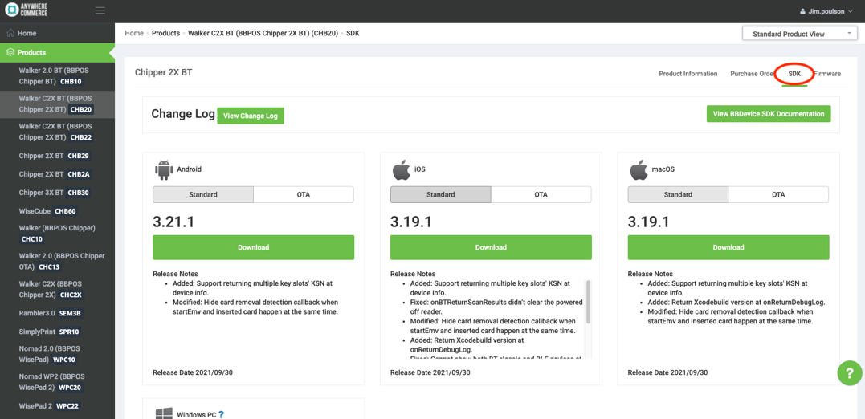

BBDEVICE for Android OTA for Android
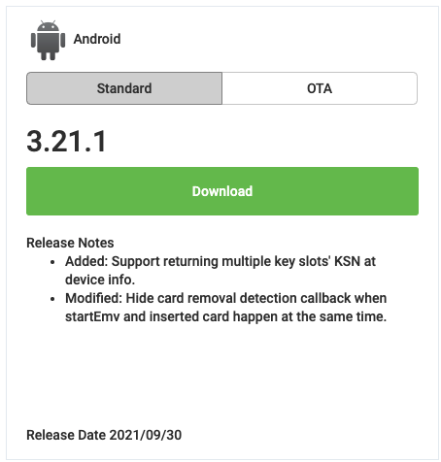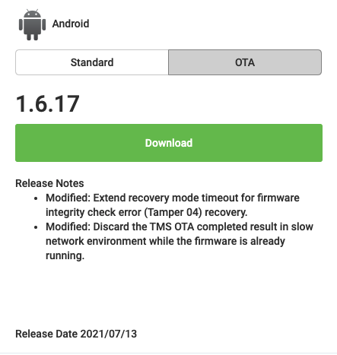

BBDEVICE for iOS OTA for iOS
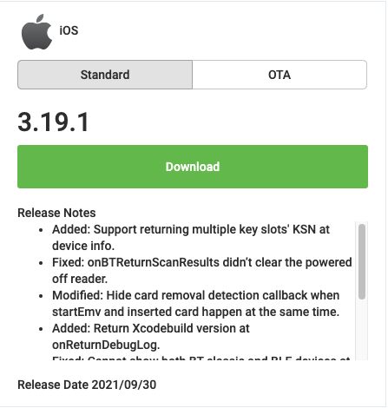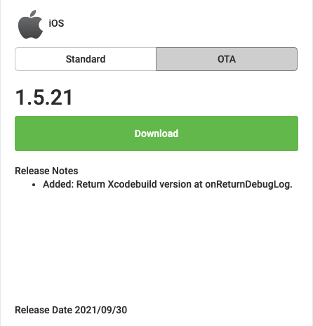

- A user can download the AnyPay Firmware OTA Updater app from the app store. These apps were created as a backup plan for clients who choose NOT to implement OTA and whose merchants will need further assistance.
  - These apps will be available on iOS App Store and Android Google Play
  - Cost of each will be $10.

